Register as a User
Go to https://urss.warwick.ac.uk/
Click Register in the top right corner:
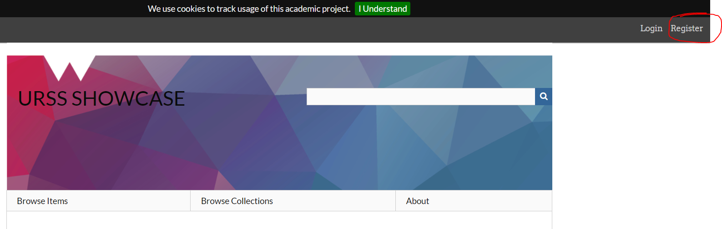
Follow Registration instructions
You MUST use your Warwick credentials, username and email address or you will not be able to register.
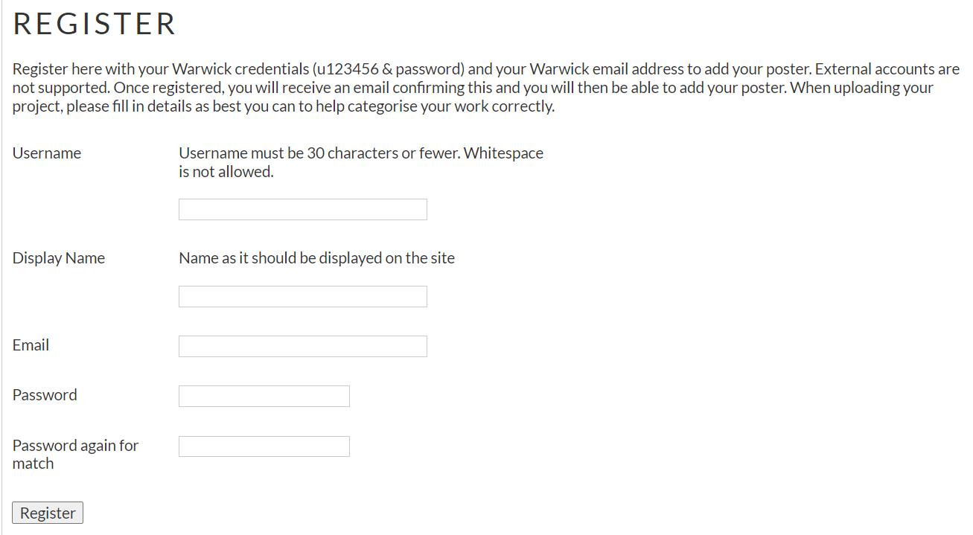
You should receive an email from Omeka with a link to verify your account and let you log in to the website. Check the Spam/Junk folder if you don’t see it.
Submitting your project
Once logged in, it will say Welcome with your name in the top right corner, if not, click the login.
You will now see a Contribute an Item link in the menu, click this.
Select the type of project you are submitting from the drop down menu and fill in the fields that appear. 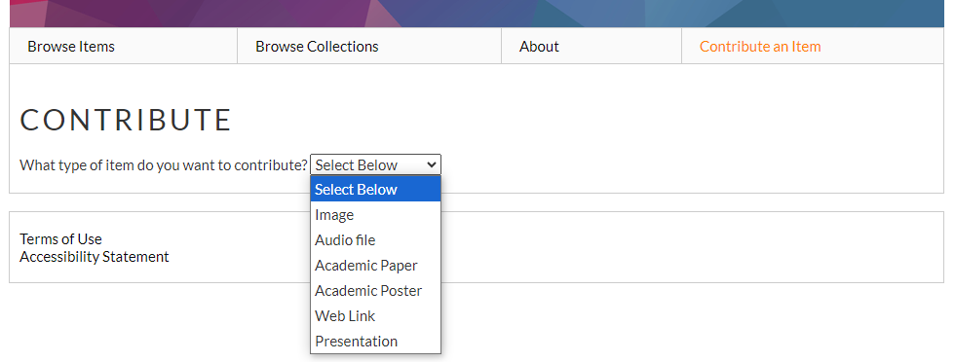

Note: The site doesn’t accept pptx files, so if you are uploading a presentation file, please save it as a 97-2003 ppt file and upload that.

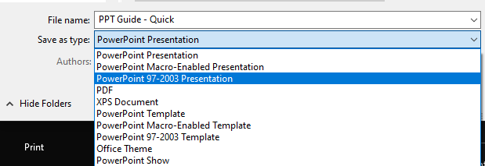
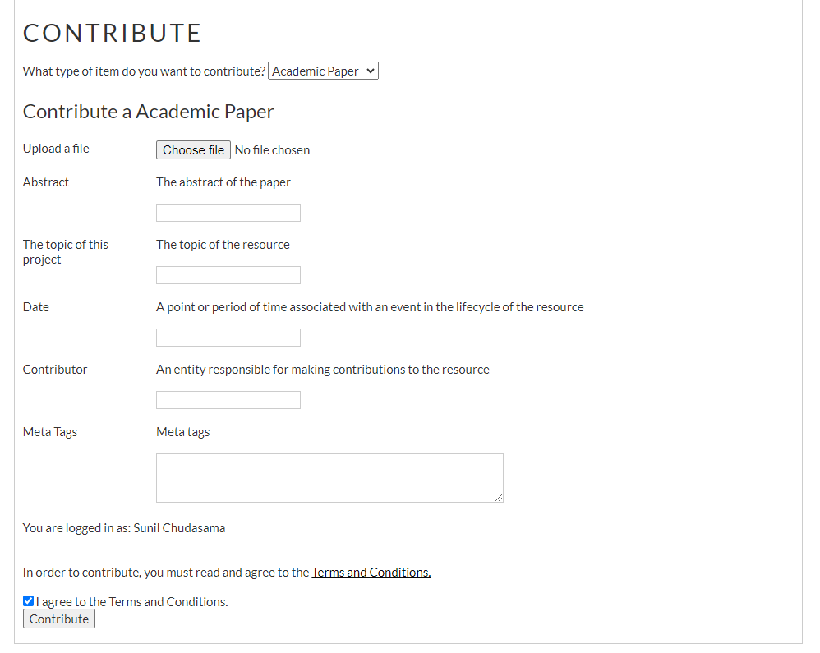
First upload your project file, then fill in the remaining fields. Check the box for agreement to the Terms & Conditions and click Contribute to submit your project.
This will trigger the moderation process for the URSS team and once this is completed, your project will be live on the site.
Note: It is important to give the correct and descriptive meta tags in the correct format, such as Tag1, tag2, tag3
This will allow for easier searching and finding of your project for visitors to the site.


