Adhoc Booking System User Guide – Step-by-step
- At the Scientia Enterprise login screen, use your university username and password to log on to the system (the same one used for logging into Insite).
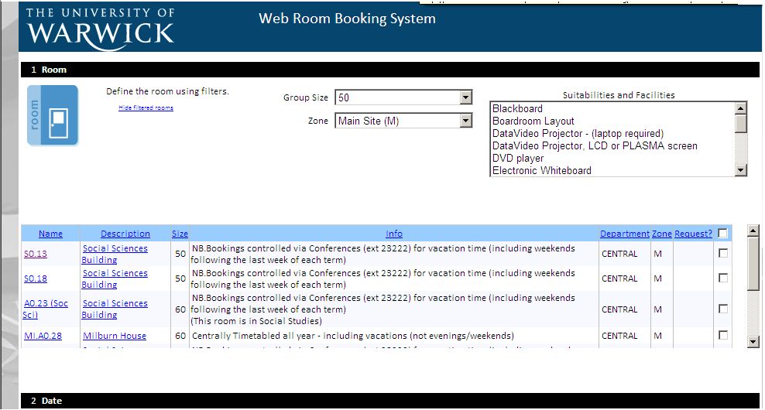
- In the first section, select the room capacity your require, the zone/zones in which you would like to book your room, and any specific facilities you may require from the room, from the right-most “suitabilities and facilities” box. Multiple selections can be made with Ctrl+click. If you are looking for a specific room, match the group size to the capacity of the room as closely as possible, as the system is only designed to show rooms within a range of the specified size, in order to avoid smaller groups booking overly-large rooms. Capacities can be checked at http://www2.warwick.ac.uk/services/its/servicessupport/av/lecturerooms/roominformation/. If you are unsure as to which rooms currently fulfil your filtering requests, you can use the “view filtered rooms” link to show which rooms apply to your current conditions. The rooms will display below the drop-down menus.

- Using the calendar interface in section 2, select the date you’d like to book the room for. If you would like to book multiple weeks/days, you can use the link to “select multiple days/weeks” on the left-hand side of the second section. Up to 5 distinct weeks may be selected this way, using Ctrl+click.
- Select the time you’d like to book the room for from section 3. Please note the majority of rooms are bookable from 9 AM – 10 PM only, with some rooms having further restrictions. Please also note that if trying to book outside of term-time, a number of rooms will be controlled by Warwick Conferences. A list of centrally-timetabled rooms during vacation periods can be found here: http://www2.warwick.ac.uk/services/centraltimetabling/roominformation/vacationrooms/.
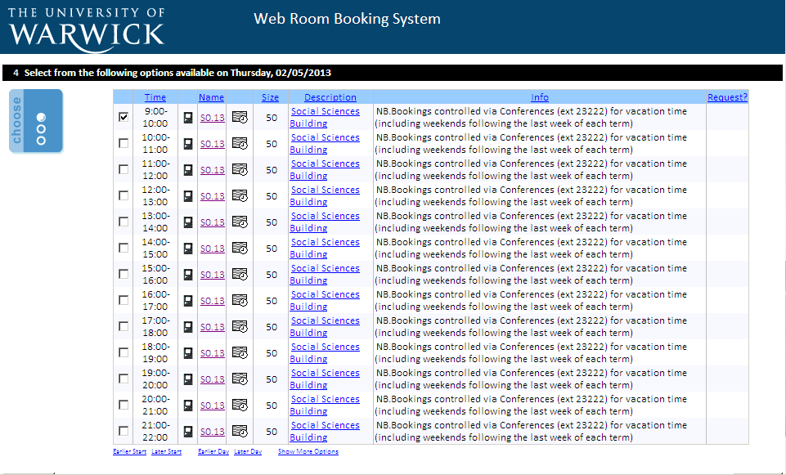
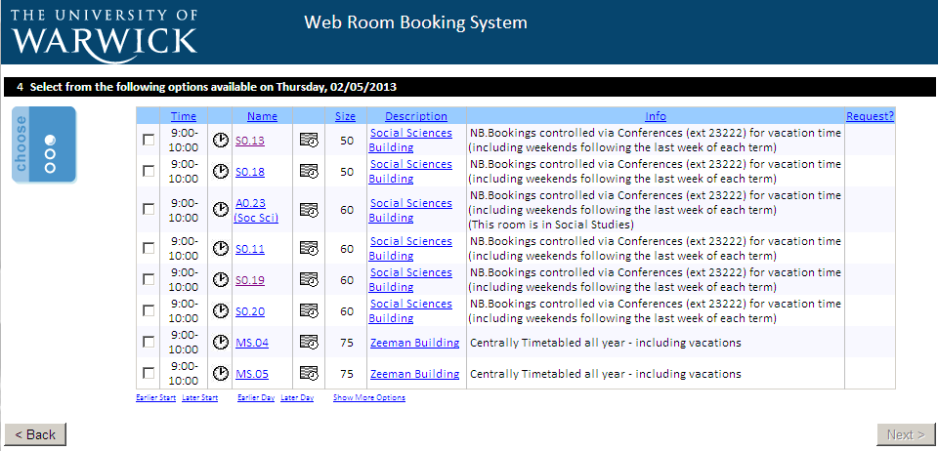
- After clicking “Next” at the bottom of the page, a list of room options will be displayed, showing which rooms meet the criteria you have specified, as well as some information about the room. The clock icons, when clicked, will show other times when that room is available on that day; the timetable icon will, in a new window, show the current timetable for that room for the specified week, and clicking the room name will take you to the timetabled room information website, with a photograph of the room also.
Clock icon view, showing availability for S0.13 on 02/05/2013.
Room name for info/photo
Timetable Icon
Clock Icon
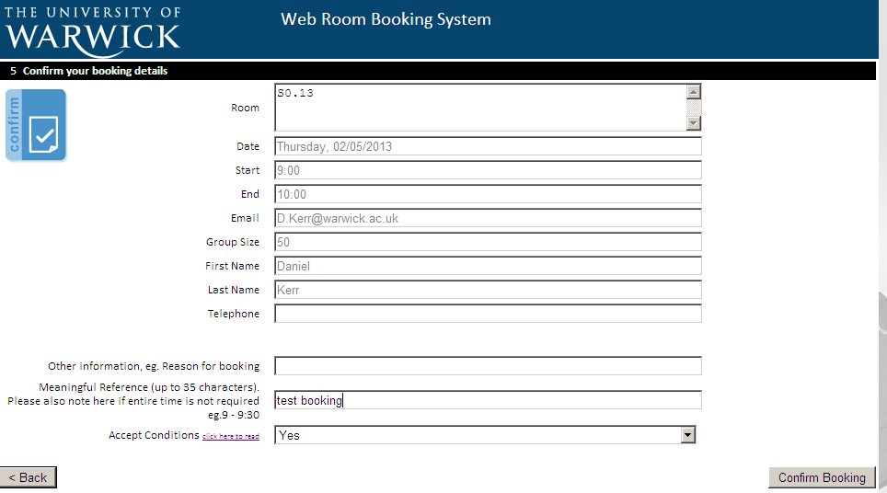
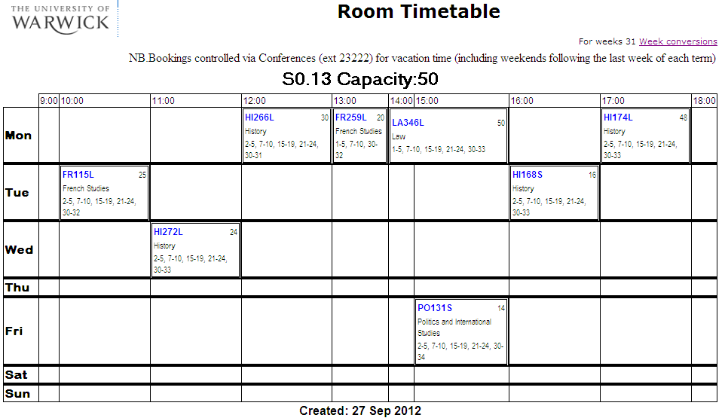
Final page of WRB system.
Timetable icon view
Meaningful Reference Box
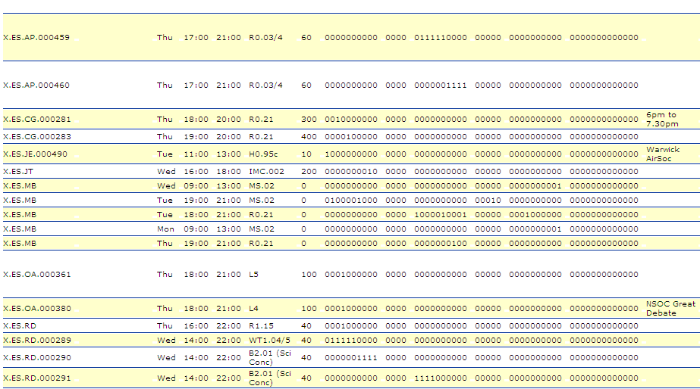
- Using the check boxes and the “Next” button, select the room/s you’d like to book for the specified period. The “Next” button will only become available once a room is selected. Finally, fill in any other information on the confirmation page, adhering to the instructions on the page, and finally press “confirm booking” in order to send your booking request. The “meaningful reference” box is used to denote any other useful information you’d like to append to the booking, particularly if you don’t require the booking for the whole slot (eg., having booked 9-11, but only requiring 9:30 – 10:30); if the booking is part of a module or connected to a module (include the module code), or any other information you think will help identify the booking to you or other people. This meaningful information will be displayed along with your booking details on AUDI, the online timetable reporting system. For example, in the activities by department report, it will be shown to the right of the booking information, like so:
- And below, in the lower-right corner on the location timetables:
Meaningful information

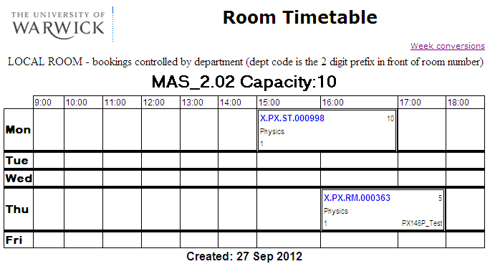
- Your request will be processed by the Central Timetabling team, and a confirmation email will be sent when the booking has been scheduled.

Checking Your Bookings
- At the bottom of any page in the WRB system, there will be two links in the centre, one to access the WRB system’s first page, and one to check bookings you have made called “My Bookings”.
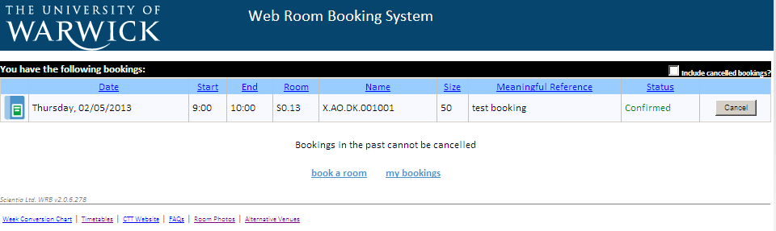
- The “My Bookings” screen:
- At this screen, you can see details of bookings that you have requested, as well as any other information you’d included with the booking, and the automatically-generated unique reference code for you booking. You should use this in any correspondence with Central Timetabling regarding your booking.
- On the far-right is a check box, to toggle the inclusion of cancelled bookings in the list, and a button to cancel the booking you have requested.
Departmental Timetabling Officers
- Departmental administrators who are registered with Central Timetabling as WRB_DEPT_USER will see an additional option on the first screen of the WRB system: “View all locations including ‘request only’”. This is due to the fact that departmental users can book their local department rooms without having to request confirmation from Central Timetabling first. Checking this option as a departmental user will allow the display of centrally-timetabled, or “request only” rooms, as well as the local rooms for your department.

