
Mobility Tool FAQ’s
You will submit your Study Abroad application using the Mobility Tool. This factsheet will highlight the key points about applying for your placement and using the Mobility Tool.
Placements
- I would like to do a work placement. Can the University of Warwick find me a place?

Answer: Unfortunately, the University cannot find you a placement. However, you may wish to speak to your department who may be able to refer you. Students are responsible for finding their own work placements.

- I want to apply for work placements but I do not have confirmation from one provider and I have yet to decide on the other. How do I complete my application?

Answer: You are advised to select the ‘I will be taking two different Work Placements this year’ option. Even if you do not have any details confirmed or you have yet to decide, you would still need to start the application process, as it shows you are expressing an interest but do not submit your application. Your application status will look like this for each placement:

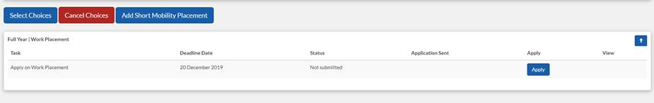
Once you have the details confirmed you can then return to your application and complete the relevant placement details. If you have details for only one placement, you can submit that application and return to the other one at a later stage so there is no need to wait for details of the other placement.

Please note: If you are looking to complete one work placement for a full year please select ‘I will be taking a Work Placement for the full year ‘and follow the instructions as set out above.

- I would like to do a study and work placement but I have not found a work placement. How do I complete my application?

Answer: You must complete and submit your study application even if you have not found a work placement as there will be an application deadline. Once you have found a work placement you can revisit your application to complete all the details and then submit it.

- I am on a British Council Assistantship placement, can I change my mind and go somewhere else?

Answer: British Council Assistantship’s are fixed for the entire duration so you cannot change your placement. Please think carefully before you submit your application.

- I have submitted my study abroad application. What happens next?

Answer: Once you have submitted your application, your department will make a decision about your application. If your application is successful, this will then be forwarded us and we will then submit the nominations to the partner institution. The partner institution is the only organisation that will confirm your place. Please check your email regularly, as the partner institution will contact you directly.

- I have submitted my application but have changed my mind about my chosen universities. What can I do?

Answer: Once you have submitted your application, you cannot amend your choices, therefore you need to think carefully before applying. However, you will need to speak to your department, who will liaise with the central team. Once the entire application process has been completed, we can then see which placements are still available.

- I would like to study at an institution that is not on your list, will I be able to take a study abroad placement there?

Answer: No, all study placements that are available to you will be shown in the list provided in the mobility tool. If you know that a particular partner placement is available but is not showing on your list, please speak to your department or contact the Student Mobility Team. Students should not be contacting any institutions to arrange placements.

Language
- I would like to go France but my placement requires me to speak French, what can I do?

Answer: Your language level must meet the required level before you leave for your placement. When you submit your application, you may not be at the right level but do not worry you have some time to improve your skills. Please seek further advice and guidance from either your department or the Language Centre.

- I am an English student and would like to study English at a German Partner University. I have been told that they teach in English but they have stipulated a language level at B2. As lessons are taught in English, does this mean I do not need to meet German at a B2 level?

Answer: Your department’s guidelines will offer advice on why proficiency in the language of your study-abroad destination is recommended. We strongly advise you to reach the minimum competency level in the language of your destination.
You cannot assume that everyone will speak English. Your study abroad placement is much more than studying. You will immersing yourself in a different environment and culture, which will enhance your experience abroad.

After Nominations
- I have submitted my application. My department and the Student Mobility Team have processed my application and I have been nominated for a placement. What happens next?

Answer: The Partner University will contact you directly. It is therefore important that you check your emails on a regular basis. Please do not contact the Partner Universities to check on the progress on your application.

Once you have been accepted on your placement, please ensure you follow the instructions set out by the Partner and provide them with the relevant details. If you are unsure, please seek assistance from your department or from the Student Mobility Team.

