Read & Write Gold

Did you know the University of Warwick holds a site licence for Read & Write Gold?
All computers in our Assistive Technology Area and Accessible Study Rooms have Read & Write Gold downloaded. We also have an area of computers within the PG Hub with it installed.
It is not restricted to these areas though! You can use it on ANY University owned and networked computers (subject to terms and conditions.)
To download the software you can follow the instructions on the IT Services web page. Please find the link below.
http://www2.warwick.ac.uk/services/its/servicessupport/software/list/readandwrite/getreadandwrite
Another way to download Read & Write Gold is via the computers Software Centre. This can be found via ‘All Programmes’ menu on the computer.
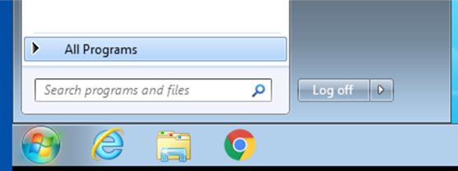
Select ‘Software Center’ which will bring up all the available software.
Then select Read & Write 11 as pictured below.
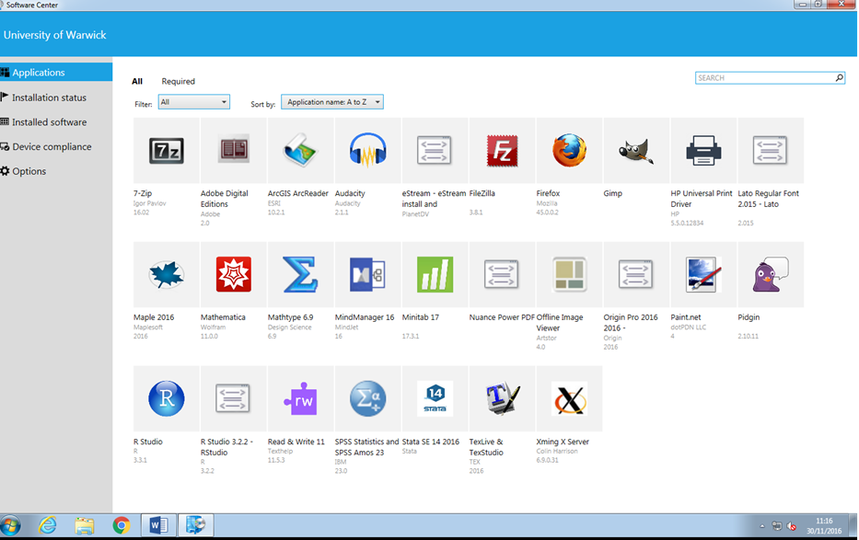
You can then select the ‘install’ link and the software will be downloaded to that computer.
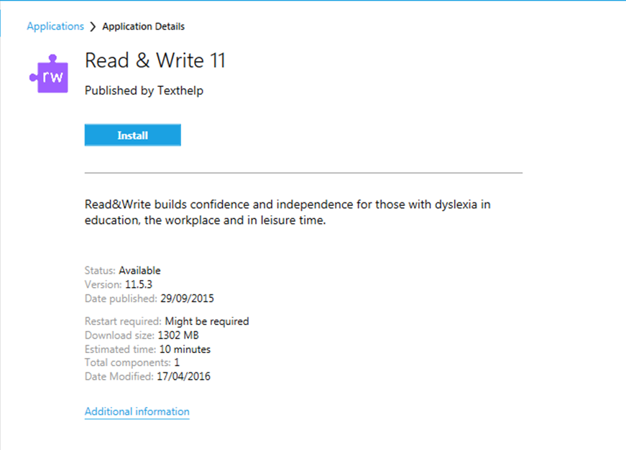
If you require any support with this please email library@warwick.ac.uk or visit the IT Helpdesk.
We are able to offer individual inductions for Read & write Gold or for any of our Assistive Software within the Library. If you are interested please contact library@warwick.ac.uk or visit the Helpdesk.
For further information regarding Read & Write Gold and some ‘getting started’ tips please visit their website found below.
https://www.texthelp.com/en-gb/support/training/getting-started

