Quiet places outside

The campus has many areas with quiet walkways, grassy fields and several lakes.
Between main campus and Gibbet Hill there are a series of lakes and woodland areas.
The cycle track and footpath adjacent to Cryfield Pavilion takes you across farm land towards Kenilworth.
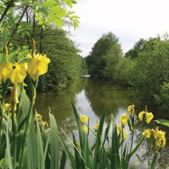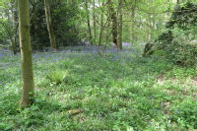

https://warwick.ac.uk/services/estates/campus/walks

Accessed from either the Humanities café or the Humanities reception area, there is an outdoor atrium with seating.

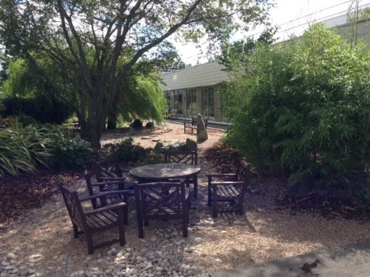

Quiet study areas

The Learning Grids around campus, especially the one in University House provide relatively quiet places to work.
The Library itself can be noisy but once you go to floor 3, 4 and 5 or ‘over the bridge’ to floor 2 you will find it is much quieter and you are expected to study in silence.
The Library has designated ‘very quiet study areas’ on floor 2, in the extension. Ask a member of staff to show you.
The Library has 7 quiet individual study rooms that you can book. There are 5 in the main library, one in the University House Learning Grid and one in the Postgraduate Hub at Junction. All are for individual use and have comfortable seating (bean bags etc). Two of the rooms in the main Library are kitted out to be ‘sensory study rooms,’ but there is also sensory lightening at University House LG2 Accessible Study Room. You’ll need to book ahead as these rooms can become busy.
Read more about these and how to book them here.
https://warwick.ac.uk/services/library/using/disability/roombookings/

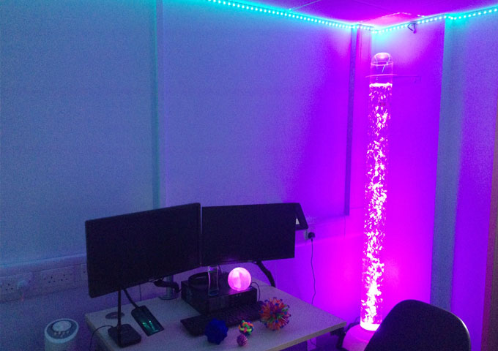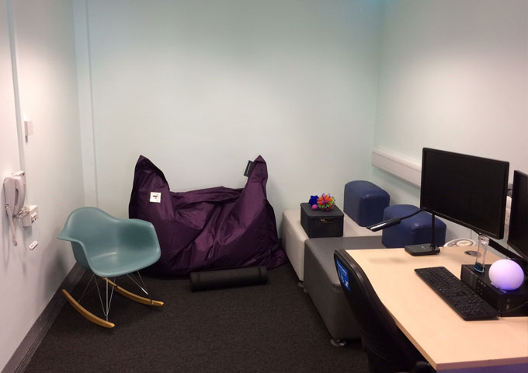

Alternative places to go

Outside exercise park near Claycroft
If you don’t like the idea of going to the gym with lots of other people or if you only want to exercise occasionally then you may be interested in the outside exercise park at the back of Claycroft. It has a variety of equipment including trampettes, an exercise bike, a cross trainer and exercise bars as well as an all-weather surface and basketball hoop.

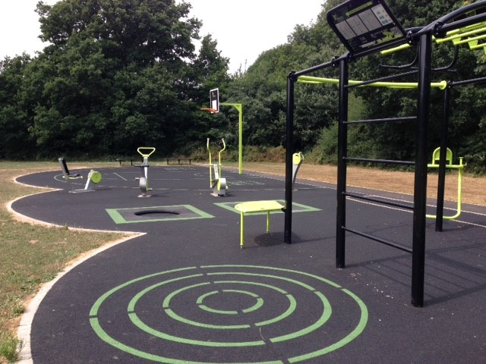

Chaplaincy

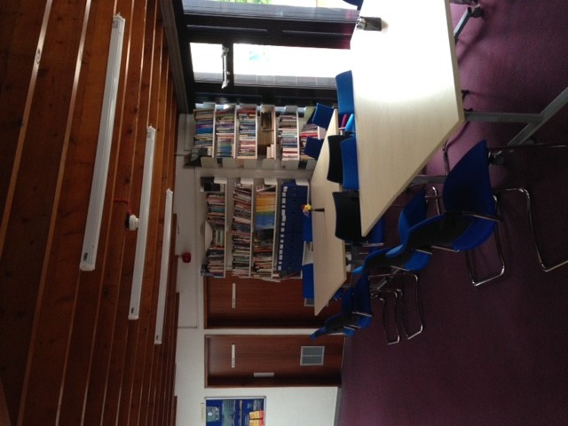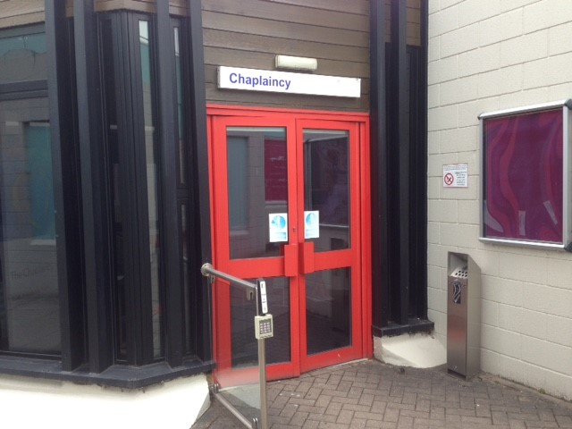

The Chaplaincy is a place of hospitality, safety, care and encounter. If you need a quiet space it offers an oasis of calm.
Staff are there for absolutely anyone, of all faiths and none.
The chaplaincy has a small kitchen where you can make a drink. There is also a small study area and there are various places to sit quietly. As you enter there is a room to the right set aside for contemplation. Providing there is no service taking place in this room you can go in and just sit quietly.
If you have a particular faith and religion, the Chaplaincy is able to help you meet with people who share your beliefs and can help make University a time of growth for you.
https://warwick.ac.uk/services/chaplaincy

