Masterclass – Call for Participation
‘Remembering From Below: New Directions in Memory Studies’
Deadline for abstracts: 14 October 2022

The VUB research group Historical Research into Urban Transformation Processes (HOST) in collaboration with the N.W. Posthumus Institute and the Fernandes Fellowship scheme of the University of Warwick is hosting the masterclass ‘Remembering From Below: New Directions in Memory Studies’ delivered by Professor Beat Kümin (Warwick, U.K.) on Friday 11 November 2022, 12-16.30, in Brussels.

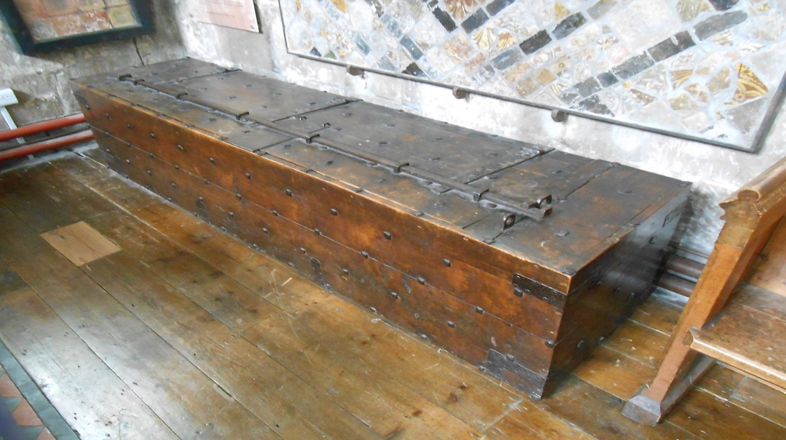
Pre-modern communities supported local memory by careful storage of documents.
Sixteenth-century parish chest at St. Peter, Winchcombe in Gloucestershire. Pic: BK.

About the speaker

Beat Kümin is Professor of Early Modern European History at the University of Warwick and author of e.g. Drinking Matters: Public Houses and Social Exchange in Early Modern Central Europe and The Communal Age in Western Europe c. 1100-1800 (published by Palgrave in 2007/2013), as well as ‘Nachrichten für die Nachwelt. Turmkugelarchive in der Erinnerungskultur des deutschsprachigen Europa [Messages for Posterity: Tower Ball Archives in the Memory Culture of German-Speaking Europe], in: Historische Zeitschrift 312 (3/2021), 614-48. He serves as an academic lead of Warwick’s interdisciplinary Global Research Priority on Food and coordinates the Warwick Network for Parish Research.
Aims of the masterclass

The masterclass ‘Remembering From Below: New Directions in Memory Studies’ offers (prospective) PhD candidates and early career researchers the opportunity to discuss their ongoing work with an expert in the field. The organisers are particularly keen to hear of fresh conceptual approaches, new types of primary sources and non-elite contexts relating to the pre-modern period, but welcome contributions on any aspect relating to the general theme. We can accommodate work in progress proposals on e.g. archival / material sources, methodological concerns, thesis chapters, funding proposals or planned publications. During the masterclass a maximum of 6 participants will offer 10-minute presentations on the basis of a pre-submitted paper (of no more than 6000 words) and discuss / gain feedback on their research. To maximize constructive exchanges, all participants are expected to read each other’s papers in advance.

How to participate

We invite researchers working on memory in the pre-modern period (and beyond) to send an abstract (c. 300 words) with a brief biographical note to host@vub.be and marjolein.schepers@kuleuven.be by 14 October 2022. All candidates will be notified of the outcome by 20 October. A full working paper should then be submitted no later than 4 November. The paper can be a chapter / section of the PhD, a draft publication, or the presentation of an entire new project. Participants are expected to briefly present their work (maximum of 10 minutes) and mainly focus on formulating some concrete questions for input and feedback. Lunch and refreshments will be provided.

We look forward to hearing from you!

