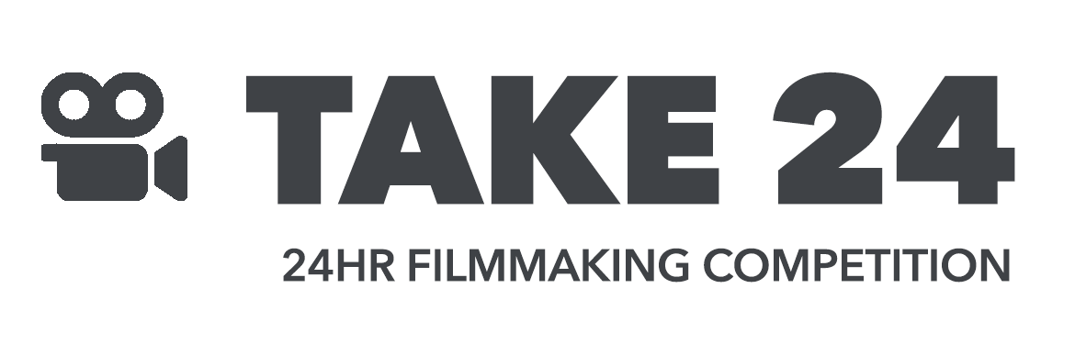
FILM SUBMISSION FORM
Checklist
Your film must be submitted with all forms by 6pm on Saturday 3 February 2024. You will need to submit:
- Your finished film as an mp4 file, less than 2GB in size, with your team name and film name in the file name.
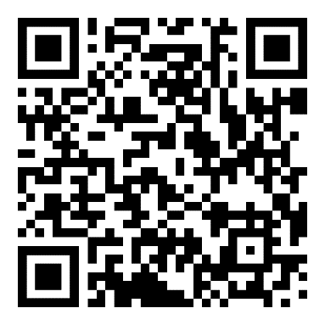
- This completed form, with your team name in the file name.
Everything must be submitted to our Dropbox.
About your film
Team Name:
Film Name:
Synopsis (max 100 words):

Performers:
Name | Role

All other credits:
Name | Role in crew

How you’ve met the Brief
Your film can be a maximum of 3 minutes and 30 seconds long and needs to include at least 3 items listed below, with at least one from each category:

Category A: Things
Item | Included (mark with X) | Timecode when visible
Mirror
Unicorn
Mask
Fedora Hat
Category B: Tropes/Cliches
Item | Included (mark with X) | Timecode when visible
Jump Scare
Spit Take
Slow Motion Running
Ticking Clock
Category C: Lines
Item | Included (mark with X) | Timecode when visible
“After all, tomorrow is another day.”
“Well, nobody’s perfect.”
“Are you not entertained?”
“That escalated quickly!”

Declaration
By submitting this form, we agree that our film meets the full rules of the competition and consent to the film being screened on campus and hosted on the University website.
Signed by team captain:

