ESREA Access, Learning Careers and Identities Network

25 – 27 November, 2015, University of Seville, Spain

First Call for Papers

Continuity and Discontinuity in Learning Careers: Potentials for a Learning Space in a Changing World
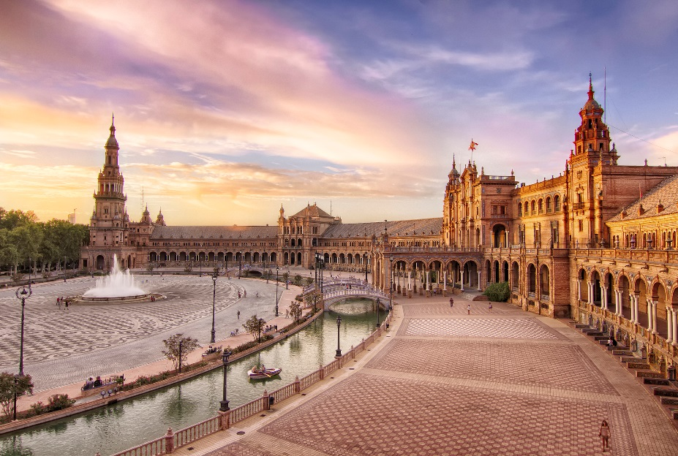
The last ESREA Access, Learning Careers and Identities Network Conference in 2013 had the ‘crisis’ as its theme. Two years on the economic crisis, which also has social and political consequences, is still with us and continues to be particularly dominant in the south of Europe. As a consequence younger and older adults are finding themselves in a labour market which either offers no jobs, low paid jobs and/or jobs with zero contracts which impacts on the self, identity and their communities.
New challenges as well as new threats are posed to adult education in such times which could both offer a potential way out of the crisis and an alternative to the dominant stories played out by the economic discourse. Within this framework continuity and discontinuity in learning careers are an interesting dimension to interrogate. In a complex way they can be conceived as two sides of the same coin, not opposite but complimentary and mutually generating and impacting upon the learning career and identity of an adult student. What individual and social choices do these processes involve and what meanings do learners give to them? What disorientating dilemmas do they bring to a person’s biography? The idea of continuity and discontinuity underlies the possibility (or the constraint) for a new personal and work life trajectory which may represent a critical moment in a person’s life. Some adults also actively choose to leave their study before finishing. Although it is a disrupted learning career it may not necessarily be a negative one. What factors at the micro, meso and macro levels come into play?
In a changing world what potential learning spaces – formal and informal- can be identified to encourage adults, particularly non-traditional adults, to learn in ways which are beneficial and positive to them as well as in ways which enables them to challenge the inequalities they experience in society?

Call for Papers, Poster Sessions and Round Tables

Papers, round-tables and poster sessions will be welcome which address one or more of the following areas across the wide range of adult education contexts:
- The role and impact of learning careers in fostering continuity or discontinuity in learning biographies
- Developing potentials for learning spaces in a changing world
- Using concepts, theory, disciplinary and inter-disciplinary approaches to understanding continuities and discontinuities in learning careers
- Inequalities of class, gender, ethnicity and disability
- Methodological approaches to researching continuities and discontinuities in learning careers

Proposals are invited for papers, poster sessions, symposiums and round tables. Please submit abstracts in two separate files: one including the paper title, the name, address, e-mail of each author and information on whether it is a paper, poster session, symposium or round table; and the second one including the paper title and abstract only. Abstracts should be one side of A4 maximum with Arial, 12 points. Please submit your abstract to Barbara Merrill (Barbara.Merrill@warwick.ac.uk).

All abstracts for papers, poster sessions, symposiums and round tables to be submitted by 1 September, 2015. Notification of acceptance will be by 15 September, 2015. The deadline for the submission of completed papers will be 6 November, 2015.

We can accept abstracts in languages other than English and which relate to the languages such as Spanish, Italian, and French.

Information for contributors of Abstracts/Papers

- A paper is proposed and submitted in the form of an abstract by one person. Other people can be named as co-authors in the abstract proposal.
- For each participant, a maximum of two such proposals may be submitted in which the person is named as an author or co-author.
- The abstract proposal must indicate which of the named authors will be presenting the paper. All those authors attending must register for the ESREA 2015 Conference for Access, Learning career and Identity.
- The author or one of the named co-authors is responsible for communicating with the ESREA conference organisers about the paper.
- The conference organisers will allocate a chairperson for each paper.
- Accepted abstracts will be downloadable in PDF-format on the Conference website. (to follow)

Further information on accommodation, travel to Seville and tourist information will be available later on the website.

Bursaries and support to participating graduate students

As a way to support graduate-student’s participation in the conference, there will be three bursaries for this conference. To be able to apply, one needs to be a graduate student (e.g. PhD-student, EdD-student, master student); a member of ESREA (either individual or covered by an institutional membership) and one need to submit a paper to the main conference.

The bursary is at the moment 300 Euros per person and should be used to cover parts of the costs for travel expenditure and/or accommodation during the conference.

Applications should be submitted no later than 30 September, 2015.

Applications or questions regarding the application procedure should be directed to the secretary of ESREA Sofia Nyström (sofia.nystrom@liu.se).

Scientific Committee
Fergal Finnegan, University of Ireland, Maynooth
Andrea Galimberti, Milano Bicocca University
Barbara Merrill, University of Warwick ,
José González Monteagudo, University of Seville
Adrianna Nizinska, University of Lower Silesia
Camilla Thunborg, University of Stockholm

Organising Committee
Barbara Merrill, University of Warwick ,
Andrea Galimberti, Milano Bicocca University
Adrianna Nizinska, University of Lower Silesia
José González Monteagudo, University of Seville

Organising Institutions
ESREA (European Society for Research on the Education of Adults) www.esrea.org ESREA promotes and disseminates theoretical and empirical research on the education of adults and adult learning in Europe through research networks, conferences and publications. It provides a Europe-wide forum for all researchers engaged in adult education and learning. The research networks hold seminars for the exchange of research and discussion and to encourage publications.

University of Seville, Spain, University of Warwick, UK. University of Lower Silesia and Milano Bicocca University

For further information about the conference please contact Barbara Merrill: Barbara.Merrill@warwick.ac.uk , Andrea Galimberti: galandre@tiscali.it
Adrianna Nizinska: Adrianna.Nizinska@dsw.edu.pl

Conference Venue

The Conference will be held at the Faculty of Education, University of Seville (Spain).
The post address of the venue is:
Faculty of Education, University of Seville
Pirotecnia street, s/n
41013-Seville (Spain).

Website of the Faculty of Education, with link to Google Maps:
https://fcce.us.es/localizacion-contacto

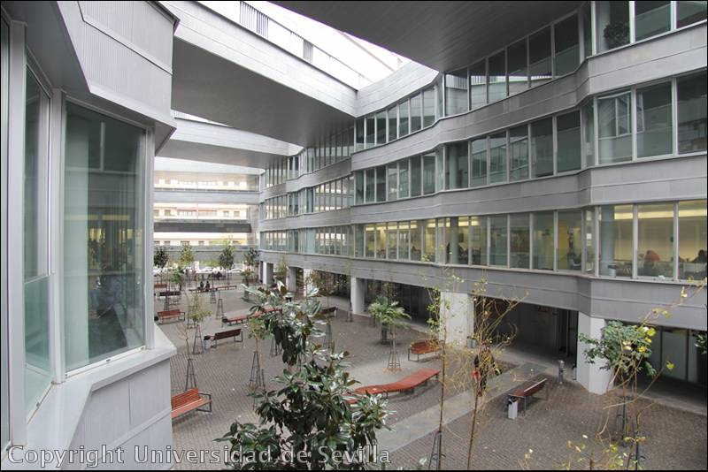

Conference Times
The conference will start at 1400 on 25 November and finish at 1300 on 27 November followed by lunch.

Conference Fees
Conference fees include morning and afternoon breaks, lunch on 26 November and lunch on 27 November after the conference finishes. It also includes dinner with drinks at a historical building on the evening of 25 November (in case it is not possible to have the dinner at a historical building, the dinner will be at the Faculty of Education and then there will be a guided tour of the historic centre, with at least two tourist guides).
The conference dinner (on the evening of 26 November) will be optional.

Conference fees are in Euros

ESREA member 110
Non-member 200
PhD students 60

The PhD student rate is not eligible to PhD who also hold a position at a university.

Further information about travel and accommodation and a registration form will be added soon.

