Widening Participation and Outreach
Safeguarding and Best Practice Principles
For all staff and external facilitators

The University strives to build a safe, positive and inclusive culture and environment for all staff and visitors to the campus.
This code outlines the principles and behavior expected of all staff working with the Outreach Team and their responsibilities towards the safeguarding of the young people in our care.
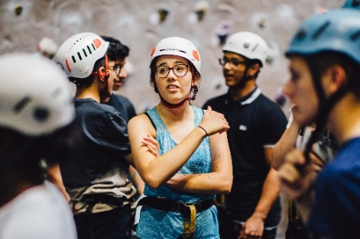
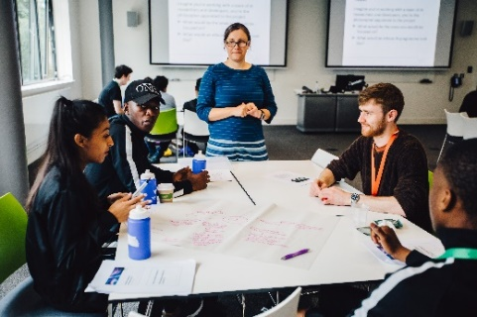
To ensure the success of our events we ask colleagues to:
- Ensure your focus is on the young people needs
- Be punctual, enthusiastic and read information/briefings prior to the event
- Let us know if you need any additional information/support ahead of the event
- Support the Team to harbor an environment of mutual respect and inclusion
- Portray the University in the best possible light
- Follow safeguarding procedures and the institutional Child Protection Policy
- Report any matter of concerns and incidents promptly to the relevant event
- Safeguarding lead (filling in relevant paperwork if necessary)
Support the young people to engage positively in all activities
All staff can expect to:
- Be given an appropriate level of information and training
- Be treated in a professional and courteous manner
- Be able to raise any concerns
- Be resourced appropriately
- Be supported in evaluating your performance in a positive and constructive manner

Child Protection and Safeguarding Statement
The Student Recruitment, Outreach and Admissions Service (SROAS) at the University of Warwick regards the safety and welfare of young people in its care to be of paramount importance. Please refer to our Child Protection and Safeguarding policy. https://warwick.ac.uk/services/gov/university-policies/safeguarding/child-protection

- I agree to challenge unacceptable behaviour and report it at an appropriate time; this could include inappropriate use of language, inappropriate banter and perhaps the use of mobile phones.
- In the case where there is cause for concern, I agree to inform immediately the Event Manager/Event Safeguarding Lead. This could include things such as overhearing a conversation that raises concerns; a young person making a disclosure; evidence of self-harm; seeing a young person in distress or observing a distressing reaction to a topic or session.
- I agree to complete any necessary documentation or write a report for child safeguarding purposes, when requested.
- I agree to avoid inappropriate physical or verbal contact with a young person and remember that my actions and lanaguage can be misinterpreted.
- I agree to always ensure that there is more than one other member of staff present with young people, according to relevant staff/young people ratios.
- I agree not to discuss individuals or incidents that have occurred except with essential staff as identified by the Event Manager and the Safeguarding Lead.
- I agree not to arrange meetings with any young people outside the event
- I agree not to give any young people my personal and social media details and not to have any direct email contact with young peoplewith my personal email address (this includes my @warwick one)
- I will contact a young people only via the Outreach team
- I agree not to enter into a relationship with a young person (during or after the event)

 | I confirm I have read and understood the above information carefully and the University Safeguarding Policy and agree to work within the standards and procedures as described.
 | Name: | Signed: | Date:

The data given on this form will be stored in accordance to the University GDPR policy.
Please note that we will ask Staff and External Facilitators to resubmit this form one a yearly basis.

