My journey and what access means to me?

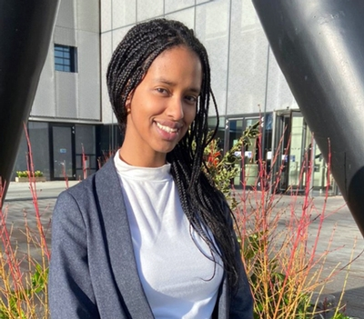

For many years, access has been instrumental in getting me to where I am today. Many people have believed in me and opened doors to an array of opportunities.

As the eldest of 4 and someone from a child refugee background, my family and I left my country, Eritrea, in pursuit of peace and freedom. The rocky journey does not stop there, we are also a low socio-economic family and lived in a cramped flat, on a council estate, for many years. Indeed, many things have felt impossible. My family and I have been met with many challenges; I have struggled with self-confidence and belittling myself. Learning has also felt very onerous, but I have persevered throughout.

A Level results day did not go accordingly however, and I felt like my dream of going to a Russell group university, Warwick, was wearying away. Without Warwick's Foundation year, I would simply not be here today.

Studying on a foundation year gave me the space to seek opportunities; last year I joined a sustainability competition, lead 6 other peers during Coventry's 2021 City of Culture Project and was supported by such encouraging lecturers, amongst many other accomplishments. This access programme and the WBS’ open mindedness, then became pivotal in allowing me to secure a full academic scholarship. An achievement that has felt surreal indeed.

"There's no denying, access has been instrumental to my success. "

For anyone that has felt like their grades are not sufficient or feel limited by their background or that there is a lack of representation at a higher education institution or any environment, do not let any external factors limit you. I am a firm believer that we are all in control of our own destiny and sometimes it is just about taking the leap of faith. There is also always someone who believes in you; If you do not take the chance, you will never know.

My words of advice:

- Whatever your struggles and challenges may be, have courage.
- The feeling of imposter syndrome may exist, but it is how you acknowledge it that truly matters.

Most importantly, tap yourself on the back, you have got this!

