Questions for Science Challenge
1.
A water tap was turned on and off again. Which graph is most likely to show what happened?
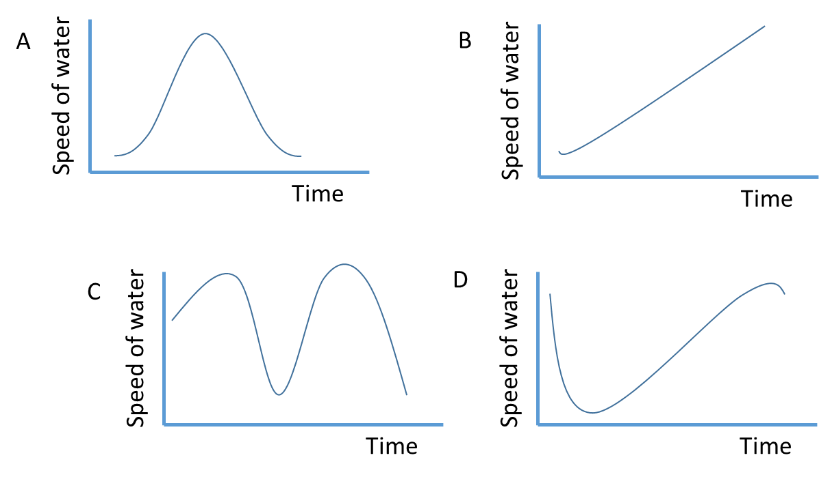

A
B
C
D
2.
One cold, frosty January day in a time before Covid, a student had a birthday party!
Inside the house, where it was nice and warm, several balloons were inflated with helium gas at the same time to the same size. Some were put outside in the cold, and some stayed inside the house in the warm.
Later that evening, the student noticed that the helium balloons put outside in the cold were all the same size as each other but did not seem to be as full as the balloons left inside.
Which statements form the most likely scientific explanation for this observation?
1: Helium had been carefully removed from the outdoor balloons
2: The temperature was colder outside than inside.
3: The volume of space occupied by a quantity of gas changes with temperature.
4: The rubber of the balloons cracked in the cold.

A: 1 and 4
B: 2 and 4
C: 2 and 3
D: 3 and 4

3.
When making a cake, if the ingredients are mixed they only rise to make a spongy cake when they are cooked. On the other hand, the ingredients for bread are mixed and kneaded and rise a lot before going into the oven to be cooked. Which of the statements below explains these observations?
1: The heat of the oven makes the cake dough expand faster than the bread dough.
2: Before cooking, the bread dough rises as a gas is being made inside the mixture.
3: The cake dough rises because a chemical reaction between the ingredients makes a gas when heated.
4: The cake mixture is made with egg and the bread dough is not.

A: 1, 2 and 3
B: 2
C: 1, 3 and 4
D: 2 and 3

4.
A teacher makes a mug of instant coffee. It seems to taste better if the order of adding ingredients to the mug is, milk, coffee, hot water rather than hot water, coffee, milk. Which statement below is likely to be the reason for this?
A: Some of the flavoured compounds in coffee escape into the air if they are made too hot
B: The coffee reacts with the milk to make a new substance.
C: The drink is less likely to burn your mouth when you are late for break duty.
D: The cold milk stops the hot water from burning the instant coffee granules.

5.
A jar of honey was left in a cupboard for a few weeks. Over time the honey turned from being runny to being solid.
Which of the statements are true?
1: The honey has “gone off” and should be thrown away.
2: Something is growing in the honey but it is safe to eat.
3: The sugar in the honey has turned into crystals
4: The honey can be made runny again by putting the whole jar into hot water for a while.

A: 1, 3 and 4
B: 3 and 4
C: 2, 3 and 4
D: 1 and 3

6.
A scientist was making dilute sulfuric acid by combining water and concentrated sulfuric acid. When water and concentrated acid mix a lot of heat is released. This can cause the acid mixture to boil and possibly splash somebody or release very harmful fumes. Which of the following suggestions would make it unlikely for the acid to boil and splash?
1: The technician must wear gloves, a lab coat and safety glasses
2: The reaction must be done in a fume cupboard
3: Pouring the acid slowly
4: To add concentrated acid to water rather than adding water to the concentrated acid.

A: 1, 2, 3 and 4
B: 3 and 4
C: 1 and 4
D: Just 3

7.
Some dry ice (chunks of solid carbon dioxide at -78 ºC) were put in a beaker at room temperature. After a few minutes, a white solid (slightly powdery) substance could be seen on some of the outside surface of the beaker.
Which of these statements are true about the white, solid, slightly powdery substance seen on the outside surface of the beaker?
1: It is dry ice reforming on the outside of the glass.
2: It has come from the glass because of the extreme cold.
3: It came from the air.
4: It is ice. Water vapour condensed and then froze on the glass.

A: 1
B: 2 and 4
C: 3 and 4
D: 1 and 2

8.
A temperature probe, connected to a computer, was set to record the temperature of a bowl of water with ice cubes in it. Which diagram shows the most likely shape of the graph recorded over the course of a couple of hours?
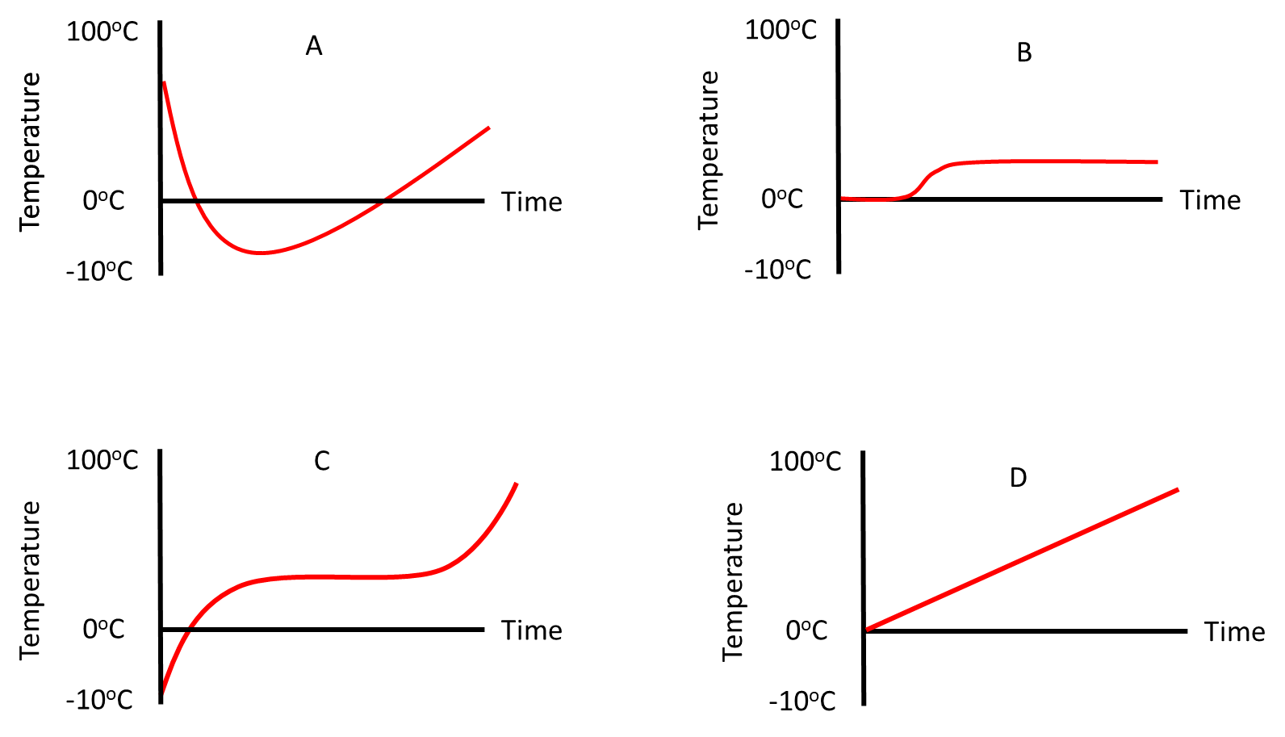

A
B
C
D
9.
A cube of sugar was added to a glass of water. Over time the cube of sugar completely dissolved. Which graph best shows what happened to the water level as the cube was added and the sugar dissolved?
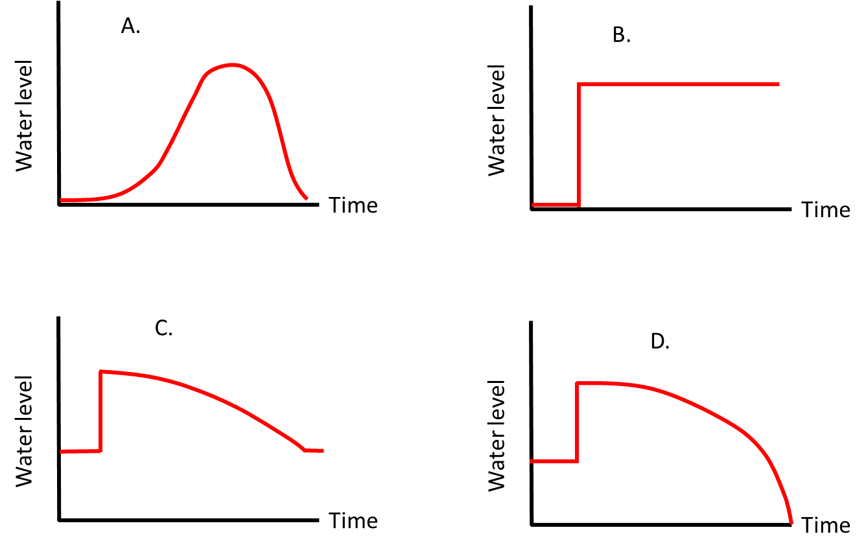

A
B
C
D
10.
When an egg is boiled some of the chemicals in the egg (called proteins) turn to solid. By timing how long the egg is boiled for, it is possible to enjoy eating an egg with solid egg white and a runny yolk. If you boil the egg for longer, both the white and the yolk will be solid.
Which of the following statements could be investigated to see if they are the reason for this?
1: The proteins in the yolk solidify at a higher temperature than the proteins in the egg white.
2: The white cooks first because it is closer to the outside of the egg and so heats up first in the hot water.
3: To turn the yolk solid simply takes longer.
4: Boiling shakes the egg and makes it jump about in the saucepan. This affects the egg white more than the yolk.

A: 1 and 3
B: 3 and 4
C: 1
D: 1, 2, 3 and 4

11.
Some smelly cheese was left on a table after lunch. It really stank! It was put away in the fridge. The next day, it was taken out of the fridge and sniffed! It didn’t seem to smell quite so bad. Why?
A: All the smelly chemicals had been released.
B: When the cheese is cold, the smelly chemicals it contains cannot evaporate into the room so easily.
C: The person had become immune to the smell.
D: The fridge had taken the smell away.

12.
A class of primary school children wanted to find out if a person’s height (in cm) was proportional to their age (in days). They measured this for every child in the school and put the best line they could through a graph of the data. They also included their teacher.
Which graph best shows what the results would have looked like?
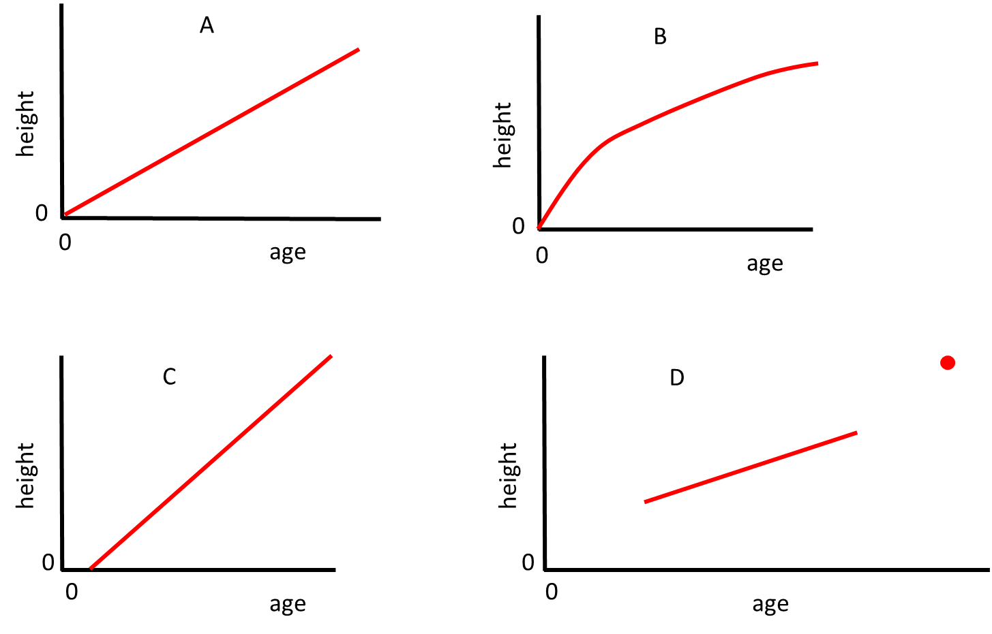
A
B
C
D

13.
This graph is taken from a recent news article:
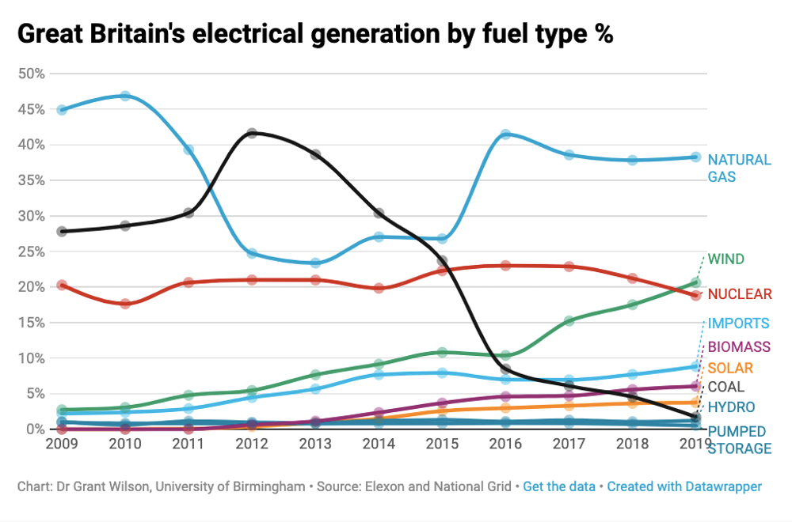
Which of these four claims is or are supported by this graph?
1: This graph shows that the climate is changing
2: The graph shows that the weather must be becoming sunnier
3: The graph shows that generation of electricity at coal fired power stations is falling as time passes.
4: The graph proves that by 2025 most of our electricity will be made by burning natural gas.

A: 1, 2, 3 and 4
B: Just 3
C: 3 and 4
D: 2, 3 and 4

14.
Back in the 1780s a scientist called Jacques Charles worked out a mathematical relationship between the amount of space (volume) a quantity of gas will fill and its temperature. It is often written like this:
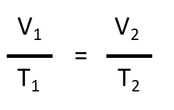
V1 = volume of the gas when you first measure it.
T1 = Temperature of the gas when you first measure it.
V2 = volume of the gas after it has been changed.
T2 = Temperature of the gas at its new, changed volume.
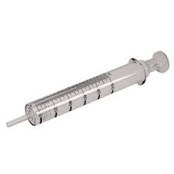
The gas being studied can be measured using something like the equipment shown. This is a gas syringe.
Which of these statements can be shown to be true from this mathematical relationship?

A: To increase the volume of gas you must lower the temperature
B: If the temperature of the gas is doubled then its volume will double
C: If the temperature of the gas is doubled then its volume will increase four times.
D: The number of gas particles in a given volume is the same whatever gas is being studied.

Chemical | Chemical Formula | Solubility in water (g per 100 cm³) at given temperatures (ºC) under 1 atmosphere pressure.
Chemical | Chemical Formula | 0 | 10 | 20 | 30 | 40 | 50 | 60 | 70 | 80 | 90 | 100
Copper(II) sulfate (hydrated) | CuSO₄.5H₂O | 23.1 | 27.5 | 32 | 37.8 | 44.6 |  | 61.8 |  | 83.8 |  | 114
Calcium nitrate (hydrated) | Ca(NO₃)₂.4H₂O | 102 | 115 | 129 | 152 | 191 |  |  |  | 358 |  | 363

The table shows how much chemical can be added to 100 cm³ of water at different temperatures and still make a solution. The maximum mass of chemical dissolved at each temperature would make a ‘saturated’ solution.
15.
How does the solubility of copper (II) sulfate (hydrated) change as the temperature of the water increases?
A: it increases
B: It decreases
C: it doubles
D: the table does not show this

16.
If you had a saturated solution of copper sulfate (hydrated) made with 100cm³ of water at 20^{O}C and heated it to 40^{O}C without losing any water, how much more copper sulfate (hydrated) could you add and still make a solution? (If it helps, copper sulfate (hydrated) is a blue powder.)
A: 114 g
B: 12.6 g
C: 62 g
D: 44.6 g

17.
If you added 500 g of calcium nitrate (hydrated) to 100 cm³ of water at 80ºC how much would not dissolve?
A: None will dissolve – it is too much
B: 360 g
C: 83.8 g
D: 142 g

18.
Which piece of laboratory measuring equipment listed below is NOT essential for the scientist to determine the information in the table.
A: Supply of pure (distilled) water
B: a clock to time the process
C: accurate weighing scales
D: a volumetric flask which accurately measures 100 ml.

19.
How many different elements are represented in the formula for copper sulfate (hydrated)?
A: 2
B: 3
C: 4
D: 5

20.
What is the total number of atoms represented in the formula for copper sulfate (hydrated)?
A: 5
B: 6
C: 19
D: 21

21.

Sulfuric Acid, H₂SO₄
Read the information and use it to answer the question below.

Sulfuric Acid is one of the world’s most used acids.
One common way of making it is to burn sulfur (brimstone) or sulfide ores in air to produce sulfur dioxide gas (SO₂).
The sulfur dioxide gas is oxidised to sulfur trioxide (SO₃) by heating in air in the presence of the catalyst vanadium pentoxide (V₂O₅).
The sulfur trioxide is then dissolved in a mixture of 98% sulfuric acid and 2% water. This produces 98.5% sulfuric acid which is then diluted back to 98%. The process then repeats.
If too much sulfur trioxide gas is added to sulfuric acid a liquid compound called oleum is produced (H₂S₂O₇)

Which of these chemical reactions is not included in the information above?
A: S + O₂ SO₂
B: H₂SO₄ + SO₃ H₂S₂O₇
C: SO₂ + H₂O H₂SO₃
D: SO₂ + ½ O₂ SO₃

Organic molecules
Study the table and answer the questions about this group of hydrocarbons called alkanes. They are often used as fuels.

Name of Alkane | General Formula | Structure | Boiling Point (bp, ºC) | Melting Point (mp, ºC)
Methane | CH₄ | CH₄ | -162 | -182
Ethane | C₂H₆ | CH₃CH₃ | -89 | -183
Propane | C₃H₈ | CH₃CH₂CH₃ | -42 | -186
Butane | (a) | CH₃CH₂CH₂CH₃ | 0 | -138
Pentane | (b) | (c) | (e) | -135
Hexane | C₆H₁₄ | (d) | 69 | -95

22.
Suggest the General Formula for butane
A: C₄H₉
B: C₃H₁₀
C: C₄H₁₀
D: C₄H₁₂

23.
What is the structure of hexane?
A: CH₃CHCHCHCHCH₃
B: CHCHCHCHCHCH
C: CH₃CH₂CH₂CH₂CH₂CH₃
D: CH₃CH₂CH₂CH₂CH₃

24.
Which of these numbers is most likely to be the boiling point of pentane in degrees centigrade (ºC)?
A: 16.1
B: 36.1
C: 56.1
D: 66.1

25.
Use the table of data to answer this: At room temperature (and normal atmospheric pressure) is hexane…
A: a liquid
B: a solid
C: a gas
D: an aqueous solution

