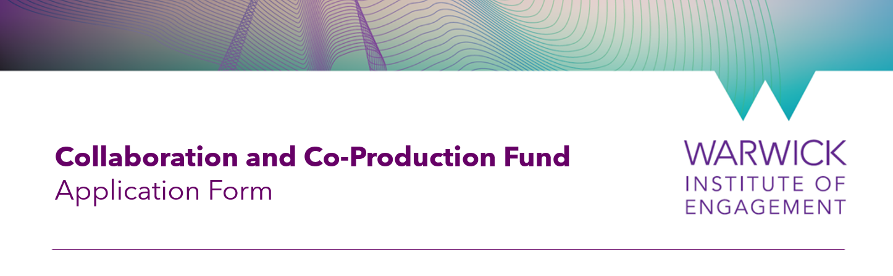

For ease of processing, we ask that applications be submitted by a member of Warwick’s staff or student community. This person is the main point of contact for the application. The main point of contact may also be the Lead Warwick Applicant.
We encourage you to use the word version of the application form provided to work together with your partner organisation to complete the application. We suggest you read through the whole from and plot out your answers first before making your final submission via this webpage.
Each staff member/ student is expected to be the lead on only one project application but can be the co-applicant on others.

Equality and Diversity Monitoring
Warwick Institute of Engagement is committed to ensuring our programmes, activities and events are accessible and inclusive. To help us to monitor our progress against this goal we ask everyone involved to register with us via this form. The data they submit will be stored by the Institute but will not be shared with the judging panel. More information about our privacy policy and use of data is available on the form.
While completing this information is not a requirement of the reporting process it would be greatly appreciated to support the continuation of it for others.

Who is the point of contact for this application?
First name Click or tap here to enter text.
Last name Click or tap here to enter text.
Email Click or tap here to enter text.

About the lead university applicant
First name Click or tap here to enter text.
Last name Click or tap here to enter text.
Role Click or tap here to enter text.
Department Click or tap here to enter text.
Faculty Choose an item.

About the lead community applicant
First name Click or tap here to enter text.
Last name Click or tap here to enter text.
Role Click or tap here to enter text.
Organisation (if applicable) Click or tap here to enter text.

About any co-applicants
If you have further co-applicants or external partners, please list their names, position, department/ organisation
Click or tap here to enter text.

About the partnership
Which of the following best describes this project? You are…
☐ building a new relationship
☐ strengthening an existing relationship

Tell us about the Warwick people involved. For example your research interests and your relevant past experiences (up to 200 words)
Click or tap here to enter text.

Tell us about the organisations you’re partnering with. For example, what they do and which audiences they work with. If applicable, please also outline what existing relationship you have that you want to develop. (Max 300 words)
Click or tap here to enter text.

Tell us why you want to work together. What are the goals for your partnership? (Short term, medium term, long term development goals. (we welcome, text, videos, images, and infographics, as part of your response) Guidance – 500 words max or 5min video/audio to be uploaded via the online webform.)
Click or tap here to enter text.

About the project
What is the name of your project? (For Example: Youth Art Workshop)
Click or tap here to enter text.

In one sentence, describe your collaborative project. (For example: We are partnering to create new opportunities for young people to engage with the arts in the city through a creative workshop.)
Click or tap here to enter text.

Tell us about your project. Eg: What are your plans and desired outcomes, what impact are you hoping to make? (we welcome text, videos, audio, images and infographics, as part of your response) Guidance – 500 words max or 5min video/audio to be uploaded via the online webform.
Click or tap here to enter text.

About the budget
Making use of the Budget template, please provide us with a breakdown of how the funds will be spent and your justification for this expenditure.

